Chain Rhyme

🔹 What is Chain Rhyme
# Source: Chatgpt (GPT-4-turbo) at [8/2/2025]
⚠️ Chain rhyme is a rhyme scheme, not a true type of homograph.
However, homographs may appear in chain rhyme if their pronunciation fits the rhyme structure.

✅ Definition of Chain Rhyme
# Source: Chatgpt (GPT-4-turbo) at [8/2/2025]
Chain rhyme (also called interlocking rhyme) is a poetic rhyme scheme in which rhyming sounds are carried over between stanzas, creating a linked, overlapping pattern.
🔁 Most common form: ABA BCB CDC…
→ Often used in forms like terza rima.

🧠 Key Features of Chain Rhyme
# Source: Chatgpt (GPT-4-turbo) at [8/2/2025]
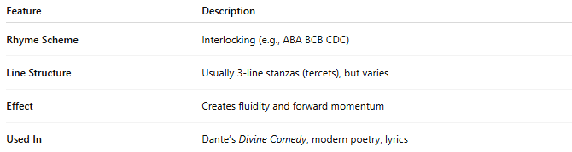
Feature | Description
Rhyme Scheme | Interlocking (e.g., ABA BCB CDC)
Line Structure | Usually 3-line stanzas (tercets), but varies
Effect | Creates fluidity and forward momentum
Used In | Dante’s Divine Comedy, modern poetry, lyrics

📝 Example of Chain Rhyme (ABA BCB CDC):
# Source: Chatgpt (GPT-4-turbo) at [8/2/2025]
A: The wind blew soft across the land
B: The stars above began to shine
A: The waves crept in and kissed the sand
B: A night as calm as vintage wine
C: The moonlight danced upon the sea
B: A peace that made the world align
- land / sand = rhyme A
- shine / wine / align = rhyme B
- sea = starts rhyme C
✅ This is chain rhyme.

🧪 Using Homographs in Chain Rhyme
# Source: Chatgpt (GPT-4-turbo) at [8/2/2025]
Homographs can work in chain rhyme only if the pronunciation supports rhyme:
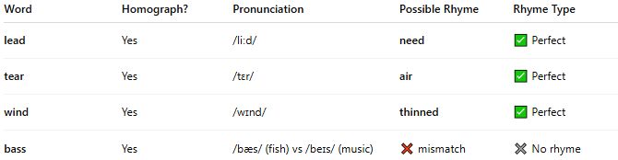
Word | Homograph? | Pronunciation | Possible Rhyme | Rhyme Type
lead | Yes | /liːd/ | need | ✅ Perfect
tear | Yes | /tɛr/ | air | ✅ Perfect
wind | Yes | /wɪnd/ | thinned | ✅ Perfect
bass | Yes | /bæs/ (fish) vs /beɪs/ (music) | ❌ mismatch | ✖ No rhyme
🔔 Warning: If the homograph is used with a different pronunciation, it won’t rhyme even if the spelling matches.

✅ Summary
# Source: Chatgpt (GPT-4-turbo) at [8/2/2025]

Aspect | Details
Type | Rhyme scheme (not word class)
Structure | Interlinked rhyme (ABA BCB CDC, etc.)
Homograph Use? | Yes, if pronunciation supports rhyme
Typical Forms | Terza rima, some lyric poetry

